CHAPTER 12
Respiration in Plants
• Respiration in Plants

12 | Food, Oxidation and the ATP Currency

All living organisms need energy for carrying out daily life activities, be it absorption, transport, movement, reproduction or even breathing. All the energy required for 'life' processes is obtained by oxidation of some macromolecules that we call 'food'.
• Green plants and cyanobacteria can prepare their own food: by photosynthesis they trap light energy and convert it into chemical energy stored in the bonds of carbohydrates like glucose, sucrose and starch.
• In green plants too, not all cells, tissues and organs photosynthesise - only cells containing chloroplasts, that are most often located in the superficial layers, carry out photosynthesis.
• Even in green plants all other organs, tissues and cells that are non-green need food for oxidation. Hence, food has to be translocated to all non-green parts.
• Animals are heterotrophic, i.e., they obtain food from plants directly (herbivores) or indirectly (carnivores).
• Saprophytes like fungi are dependent on dead and decaying matter.
So ultimately all the food that is respired for life processes comes from photosynthesis. Photosynthesis takes place within the chloroplasts (in the eukaryotes), whereas the breakdown of complex molecules to yield energy takes place in the cytoplasm and in the mitochondria (also only in eukaryotes).
• Respiration: the breaking of the C-C bonds of complex compounds through oxidation within the cells, leading to release of considerable amount of energy.
• Respiratory substrates: the compounds that are oxidised during this process. Usually carbohydrates are oxidised to release energy, but proteins, fats and even organic acids can be used as respiratory substances in some plants, under certain conditions.
During oxidation within a cell, all the energy contained in respiratory substrates is not released free into the cell, or in a single step. It is released in a series of slow step-wise reactions controlled by enzymes, and it is trapped as chemical energy in the form of ATP. The energy released by oxidation in respiration is not (or rather cannot be) used directly but is used to synthesise ATP, which is broken down whenever (and wherever) energy needs to be utilised. Hence ATP acts as the energy currency of the cell.
[NOTE] Respiration does not only pay the energy bill. The carbon skeleton produced during respiration is used as precursors for biosynthesis of other molecules in the cell - the point SS12.6 returns to as the amphibolic nature of the pathway.

12.1 | Do Plants Breathe?

The answer to this question is not quite so direct. Yes, plants require O₂ for respiration to occur and they also give out CO₂. But plants, unlike animals, have no specialised organs for gaseous exchange - they have stomata and lenticels for this purpose.
12.1a | Why No Respiratory System Is Needed

Reason | What NCERT states
Each part is on its own | Each plant part takes care of its own gas-exchange needs. There is very little transport of gases from one plant part to another.
The demand is low | Plants do not present great demands for gas exchange. Roots, stems and leaves respire at rates far lower than animals do.
Peak demand is self-served | Only during photosynthesis are large volumes of gases exchanged, and each leaf is well adapted to take care of its own needs during these periods. When cells photosynthesise, availability of O₂ is not a problem in these cells since O₂ is released within the cell.
Diffusion distances are short | The distance that gases must diffuse even in large, bulky plants is not great. Each living cell in a plant is located quite close to the surface of the plant. In stems, the 'living' cells are organised in thin layers inside and beneath the bark; they also have openings called lenticels. The cells in the interior are dead and provide only mechanical support.
Air reaches the cells | Most cells of a plant have at least a part of their surface in contact with air. This is also facilitated by the loose packing of parenchyma cells in leaves, stems and roots, which provide an interconnected network of air spaces.

The complete combustion of glucose, which produces CO₂ and H₂O as end products, yields energy most of which is given out as heat:
C₆H₁₂O₆ + 6O₂ yields 6CO₂ + 6H₂O + Energy
The key is to oxidise glucose not in one step but in several small steps, enabling some steps to be just large enough such that the energy released can be coupled to ATP synthesis. During the process of respiration, oxygen is utilised, and carbon dioxide, water and energy are released as products.
12.1b | The Anaerobic Legacy

There are sufficient reasons to believe that the first cells on this planet lived in an atmosphere that lacked oxygen. Even among present-day living organisms, we know of several that are adapted to anaerobic conditions. Some of these organisms are facultative anaerobes, while in others the requirement for anaerobic condition is obligate. In any case, all living organisms retain the enzymatic machinery to partially oxidise glucose without the help of oxygen.
• Glycolysis: this breakdown of glucose to pyruvic acid.
12.2 | Glycolysis

The term glycolysis has originated from the Greek words, glycos for sugar, and lysis for splitting. The scheme of glycolysis was given by Gustav Embden, Otto Meyerhof, and J. Parnas, and is often referred to as the EMP pathway.
• In anaerobic organisms, it is the only process in respiration.
• Glycolysis occurs in the cytoplasm of the cell and is present in all living organisms.
• In this process, glucose undergoes partial oxidation to form two molecules of pyruvic acid.
In plants, this glucose is derived from sucrose, which is the end product of photosynthesis, or from storage carbohydrates. Sucrose is converted into glucose and fructose by the enzyme, invertase, and these two monosaccharides readily enter the glycolytic pathway. Glucose and fructose are phosphorylated to give rise to glucose-6-phosphate by the activity of the enzyme hexokinase. This phosphorylated form of glucose then isomerises to produce fructose-6-phosphate. Subsequent steps of metabolism of glucose and fructose are same.
12.2a | The Ten Reactions, Step by Step

In glycolysis, a chain of ten reactions, under the control of different enzymes, takes place to produce pyruvate from glucose.
1 | Glucose (6C) is phosphorylated to glucose-6-phosphate (6C) by hexokinase - ATP is utilised here (first of the two ATP-spending steps) and ADP is released.
2 | Glucose-6-phosphate isomerises to fructose-6-phosphate (6C).
3 | Fructose 6-phosphate to fructose 1,6-bisphosphate (6C) - the second step at which ATP is utilised.
4 | The fructose 1,6-bisphosphate is split into the two triose phosphates: dihydroxyacetone phosphate (3C) and 3-phosphoglyceraldehyde, PGAL - also written glyceraldehyde-3-phosphate (3C).
5 | PGAL to 1,3-bisphosphoglycerate (BPGA): this is the one step where NADH + H⁺ is formed from NAD⁺. Two redox-equivalents are removed (in the form of two hydrogen atoms) from PGAL and transferred to a molecule of NAD⁺; PGAL is oxidised and with inorganic phosphate to get converted into BPGA. As a triose bisphosphate, BPGA is the 1,3-bisphosphoglyceric acid (3C) of the chart.
6 | BPGA to 3-phosphoglyceric acid (PGA) - the triose phosphate 3-phosphoglyceric acid (3C). This is also an energy yielding process; this energy is trapped by the formation of ATP.
7 | PGA to 2-phosphoglycerate.
8 | 2-phosphoglycerate loses H₂O to give phosphoenolpyruvate (PEP).
9 | Another ATP is synthesised during the conversion of PEP to pyruvic acid.
10 | Pyruvic acid (3C) is then the key product of glycolysis.

What is the metabolic fate of pyruvate? This depends on the cellular need. There are three major ways in which different cells handle pyruvic acid produced by glycolysis.
Fate of pyruvic acid | Conditions | Outcome
Lactic acid fermentation | Anaerobic | Incomplete oxidation; pyruvic acid is reduced to lactic acid
Alcoholic fermentation | Anaerobic | Incomplete oxidation; pyruvic acid is converted to CO₂ and ethanol
Aerobic respiration | Requires O₂ supply | Complete oxidation of glucose to CO₂ and H₂O through Krebs' cycle

Fermentation takes place under anaerobic conditions in many prokaryotes and unicellular eukaryotes. For the complete oxidation of glucose to CO₂ and H₂O, however, organisms adopt Krebs' cycle which is also called as aerobic respiration. This requires O₂ supply.
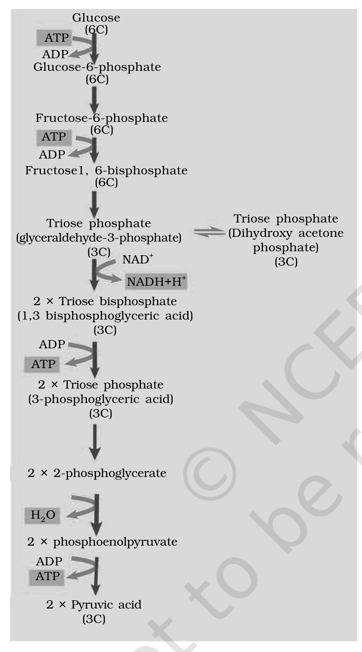
Fig. 12.1 - Steps of glycolysis. The chart runs from Glucose (6C) down through Glucose-6-phosphate (6C) and Fructose-6-phosphate (6C) - each of the first two steps spending one ATP and releasing ADP - to Fructose 1,6-bisphosphate (6C), which splits into the Triose phosphate dihydroxyacetone phosphate (3C) and the Triose phosphate glyceraldehyde-3-phosphate (3C). The latter, with NAD⁺ reduced to NADH + H⁺, becomes the Triose bisphosphate 1,3-bisphosphoglyceric acid (3C), then the Triose phosphate 3-phosphoglyceric acid (3C), then 2-phosphoglycerate, which loses H₂O to give phosphoenolpyruvate and finally Pyruvic acid (3C).
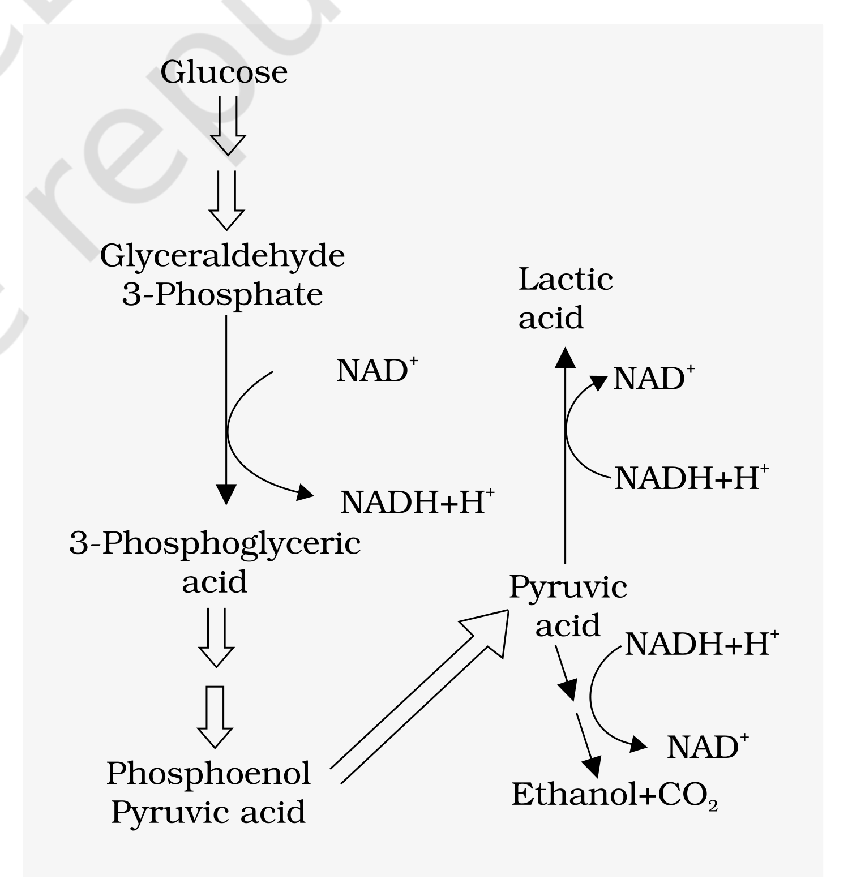
Fig. 12.2 - Major pathways of anaerobic respiration. Glucose passes through Glyceraldehyde 3-phosphate, 3-phosphoglyceric acid and phosphoenol pyruvic acid to Pyruvic acid, which then branches either to Lactic acid or to Ethanol plus CO₂. NAD⁺ and NADH + H⁺ are shown being interconverted along the pathway, since the reducing power taken out of the sugar is handed back at the branch.
12.3 | Fermentation

In fermentation, say by yeast, the incomplete oxidation of glucose is achieved under anaerobic conditions by sets of reactions where pyruvic acid is converted to CO₂ and ethanol. The enzymes, pyruvic acid decarboxylase and alcohol dehydrogenase catalyse these reactions.
• Other organisms like some bacteria produce lactic acid from pyruvic acid.
• In animal cells also, like muscles during exercise, when oxygen is inadequate for cellular respiration pyruvic acid is reduced to lactic acid by lactate dehydrogenase.
• The reducing agent is NADH + H⁺, which is reoxidised to NAD⁺ in both the processes.
12.3a | Why Fermentation Is a Poor Deal

• Less than seven per cent of the energy in glucose is released, and not all of it is trapped as high energy bonds of ATP.
• Also, the processes are hazardous - either acid or alcohol is produced.
• Yeasts poison themselves to death when the concentration of alcohol reaches about 13 per cent.
[NOTE] Where fermentation happens: under anaerobic conditions in many prokaryotes, unicellular eukaryotes and in germinating seeds.

12.3b | The Aerobic Alternative

• Aerobic respiration: the process that leads to a complete oxidation of organic substances in the presence of oxygen, and releases CO₂, water and a large amount of energy present in the substrate.
This type of respiration is most common in higher organisms. In eukaryotes these steps take place within the mitochondria and this requires O₂.

12.4 | Aerobic Respiration

For aerobic respiration to take place within the mitochondria, the final product of glycolysis, pyruvate is transported from the cytoplasm into the mitochondria. Two crucial events then follow:
1 | The complete oxidation of pyruvate by the stepwise removal of all the hydrogen atoms, leaving three molecules of CO₂. This first process takes place in the matrix of the mitochondria.
2 | The passing on of the electrons removed as part of the hydrogen atoms to molecular O₂ with simultaneous synthesis of ATP. This second process is located on the inner membrane of the mitochondria.

Pyruvate, which is formed by the glycolytic catabolism of carbohydrates in the cytosol, after it enters mitochondrial matrix undergoes oxidative decarboxylation by a complex set of reactions catalysed by pyruvic dehydrogenase. These reactions require the participation of several coenzymes, including NAD⁺ and Coenzyme A:
Pyruvic acid + CoA + NAD⁺ (with Mg²⁺ and pyruvate dehydrogenase) yields Acetyl CoA + CO₂ + NADH + H⁺
During this process, two molecules of NADH are produced from the metabolism of two molecules of pyruvic acid (produced from one glucose molecule during glycolysis). The acetyl CoA then enters a cyclic pathway, tricarboxylic acid cycle, more commonly called as Krebs' cycle after the scientist Hans Krebs who first elucidated it.
12.4.1 | Tricarboxylic Acid Cycle

1 | (cycle - last step feeds back to step 1)
2 | The TCA cycle starts with the condensation of acetyl group with oxaloacetic acid (OAA) and water to yield citric acid. The reaction is catalysed by the enzyme citrate synthase and a molecule of CoA is released.
3 | Citrate is then isomerised to isocitrate.
4 | It is followed by two successive steps of decarboxylation, leading to the formation of alpha-ketoglutaric acid and then succinyl-CoA.
5 | During the conversion of succinyl-CoA to succinic acid a molecule of GTP is synthesised. This is a substrate level phosphorylation. In a coupled reaction GTP is converted to GDP with the simultaneous synthesis of ATP from ADP.
6 | In the remaining steps of citric acid cycle, succinyl-CoA is oxidised to OAA allowing the cycle to continue.

• There are three points in the cycle where NAD⁺ is reduced to NADH + H⁺ and one point where FAD⁺ is reduced to FADH₂.
• The continued oxidation of acetyl CoA via the TCA cycle requires the continued replenishment of oxaloacetic acid, the first member of the cycle.
• In addition it also requires regeneration of NAD⁺ and FAD⁺ from NADH and FADH₂ respectively.
The summary equation for this stage of respiration, in the mitochondrial matrix, may thus be written as:
Pyruvic acid + 4NAD⁺ + FAD⁺ + 2H₂O + ADP + P_{i} yields 3CO₂ + 4NADH + 4H⁺ + FADH₂ + ATP
By the end of the cycle, glucose has been broken down to release CO₂ and eight molecules of NADH + H⁺ and two of FADH₂ have been synthesised, besides just two molecules of ATP in TCA cycle.
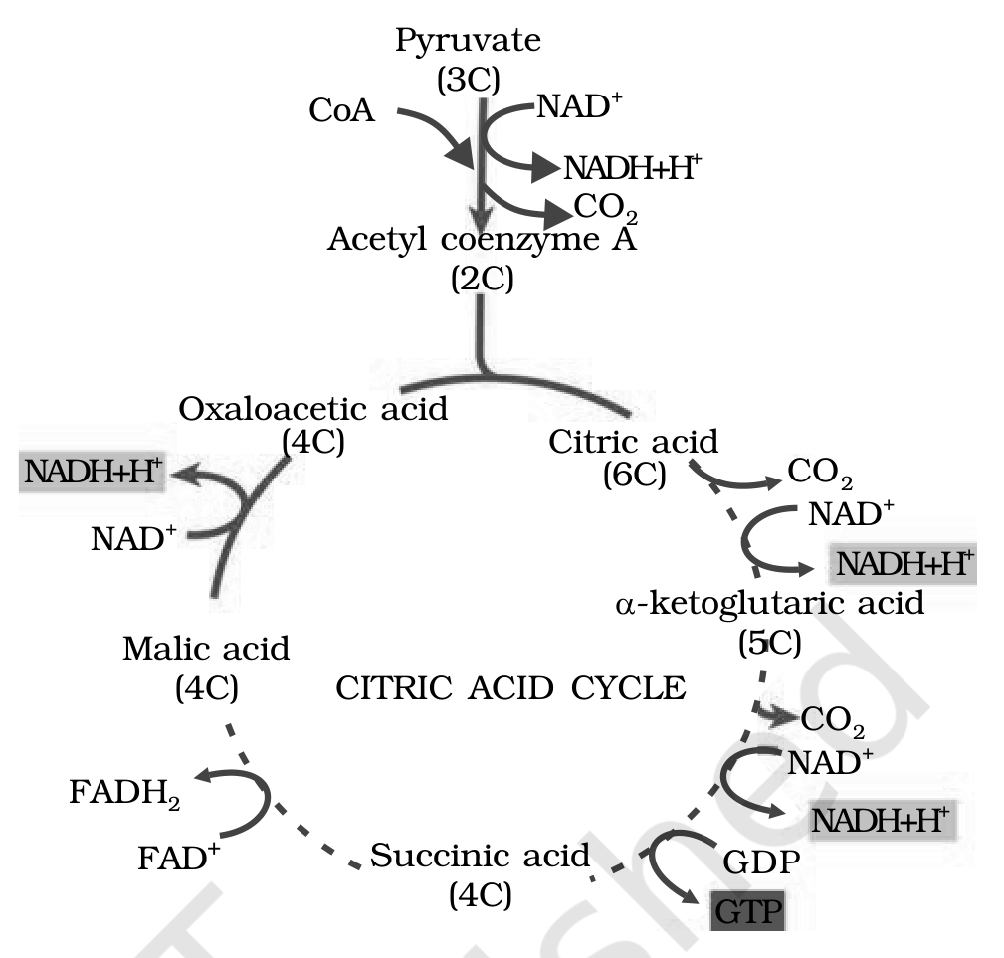
Fig. 12.3 - The Citric acid cycle. Pyruvate (3C) loses CO₂ and, with CoA and NAD⁺ reduced to NADH + H⁺, gives Acetyl coenzyme A (2C), which condenses with Oxaloacetic acid (4C) to form Citric acid (6C). Around the ring, decarboxylations give alpha-ketoglutaric acid (5C) and then, via Succinic acid (4C) - the step in which GDP becomes GTP - and Malic acid (4C), the cycle returns to oxaloacetic acid. FAD⁺ to FADH₂ marks the single flavin-linked oxidation.
12.4.2 | Electron Transport System (ETS) and Oxidative Phosphorylation

The following steps in the respiratory process are to release and utilise the energy stored in NADH + H⁺ and FADH₂. This is accomplished when they are oxidised through the electron transport system and the electrons are passed on to O₂ resulting in the formation of H₂O.
• Electron transport system (ETS): the metabolic pathway through which the electron passes from one carrier to another. It is present in the inner mitochondrial membrane.
1 | Electrons from NADH produced in the mitochondrial matrix during citric acid cycle are oxidised by an NADH dehydrogenase (complex I), and electrons are then transferred to ubiquinone located within the inner membrane.
2 | Ubiquinone also receives reducing equivalents via FADH₂ (complex II) that is generated during oxidation of succinate in the citric acid cycle.
3 | The reduced ubiquinone (ubiquinol) is then oxidised with the transfer of electrons to cytochrome c via cytochrome bc₁ complex (complex III).
4 | Cytochrome c is a small protein attached to the outer surface of the inner membrane and acts as a mobile carrier for transfer of electrons between complex III and IV.
5 | Complex IV refers to cytochrome c oxidase complex containing cytochromes a and a₃, and two copper centres.
6 | When the electrons pass from one carrier to another via complex I to IV in the electron transport chain, they are coupled to ATP synthase (complex V) for the production of ATP from ADP and inorganic phosphate.

The number of ATP molecules synthesised depends on the nature of the electron donor.
Electron donor oxidised | ATP produced
One molecule of NADH | 3 molecules of ATP
One molecule of FADH₂ | 2 molecules of ATP

Although the aerobic process of respiration takes place only in the presence of oxygen, the role of oxygen is limited to the terminal stage of the process. Yet the presence of oxygen is vital, since it drives the whole process by removing hydrogen from the system: oxygen acts as the final hydrogen acceptor.
• Oxidative phosphorylation: unlike photophosphorylation where it is the light energy that is utilised for the production of proton gradient required for phosphorylation, in respiration it is the energy of oxidation-reduction utilised for the same process. It is for this reason that the process is called oxidative phosphorylation.
You have already studied about the mechanism of membrane-linked ATP synthesis as explained by the chemiosmotic hypothesis in the earlier chapter.
12.4.2a | ATP Synthase - the F₁/F₀ Machine

The energy released during the electron transport system is utilised in synthesising ATP with the help of ATP synthase (complex V). This complex consists of two major components, F₁ and F₀.
• The F₁ headpiece is a peripheral membrane protein complex and contains the site for synthesis of ATP from ADP and inorganic phosphate.
• F₀ is an integral membrane protein complex that forms the channel through which protons cross the inner membrane.
• The passage of protons through the channel is coupled to the catalytic site of the F₁ component for the production of ATP.
• For each ATP produced, 4H⁺ pass through F₀ from the intermembrane space to the matrix down the electrochemical proton gradient.
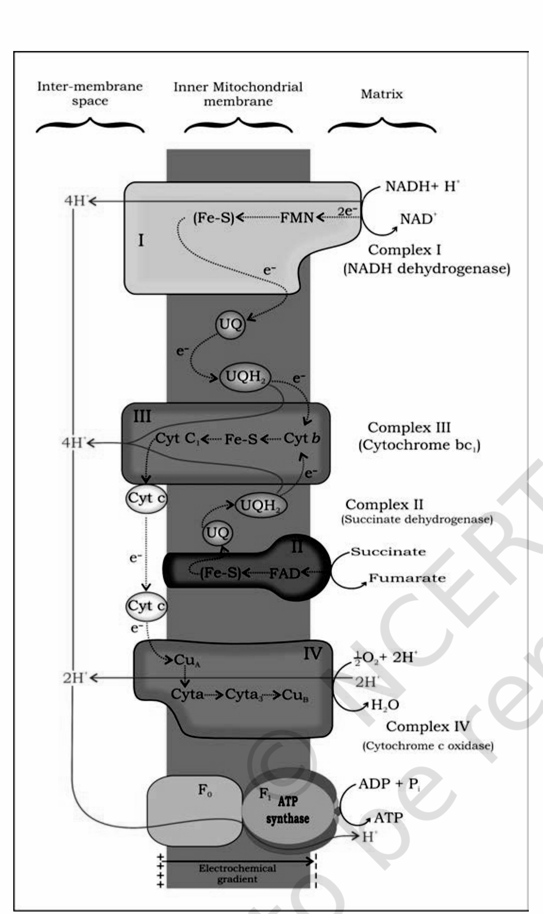 | 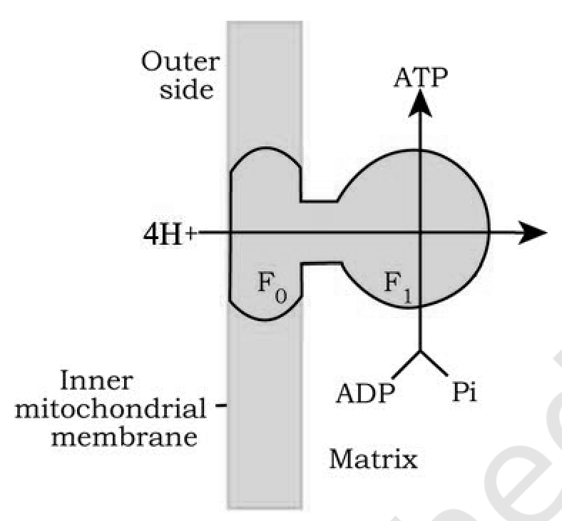

12.5 | The Respiratory Balance Sheet

It is possible to make calculations of the net gain of ATP for every glucose molecule oxidised; but in reality this can remain only a theoretical exercise. The calculations can be made only on certain assumptions:
• There is a sequential, orderly pathway functioning, with one substrate forming the next and with glycolysis, TCA cycle and ETS pathway following one after another.
• The NADH synthesised in glycolysis is transferred into the mitochondria and undergoes oxidative phosphorylation.
• None of the intermediates in the pathway are utilised to synthesise any other compound.
• Only glucose is being respired - no other alternative substrates are entering in the pathway at any of the intermediary stages.
[NOTE] None of these assumptions is strictly valid in a living system: all pathways work simultaneously and do not take place one after another; substrates enter the pathways and are withdrawn from it as and when necessary; ATP is utilised as and when needed; enzymatic rates are controlled by multiple means.

With the assumptions above, there can be a net gain of 38 ATP molecules during aerobic respiration of one molecule of glucose.
12.5a | Fermentation vs Aerobic Respiration

Point of difference | Fermentation | Aerobic respiration
Extent of breakdown | Accounts for only a partial breakdown of glucose | Glucose is completely degraded to CO₂ and H₂O
Net ATP gain | Net gain of only two molecules of ATP for each molecule of glucose degraded to pyruvic acid | Many more molecules of ATP are generated under aerobic conditions
Oxidation of NADH to NAD⁺ | Rather slow | Very vigorous

12.6 | Amphibolic Pathway

Glucose is the favoured substrate for respiration. All carbohydrates are usually first converted into glucose before they are used for respiration. Other substrates can also be respired, as has been mentioned earlier, but then they do not enter the respiratory pathway at the first step.
Substrate | Broken down first into | Enters the respiratory pathway as
Fats | Glycerol and fatty acids | Fatty acids would first be degraded to acetyl CoA and enter the pathway; glycerol would enter the pathway after being converted to PGAL
Proteins | Individual amino acids, by proteases | The amino acids, after deamination, depending on their structure would enter the pathway at some stage within the Krebs' cycle or even as pyruvate or acetyl CoA

Since respiration involves breakdown of substrates, the respiratory process has traditionally been considered a catabolic process and the respiratory pathway as a catabolic pathway. But the same intermediates are also drawn off for synthesis: when the organism needs to synthesise fatty acids, acetyl CoA would be withdrawn from the respiratory pathway for it. Similarly, during breakdown and synthesis of protein too, respiratory intermediates form the link.
• Catabolism and anabolism: breaking down processes within the living organism is catabolism, and synthesis is anabolism.
• Amphibolic pathway: because the respiratory pathway is involved in both anabolism and catabolism, it would hence be better to consider the respiratory pathway as an amphibolic pathway rather than as a catabolic one.
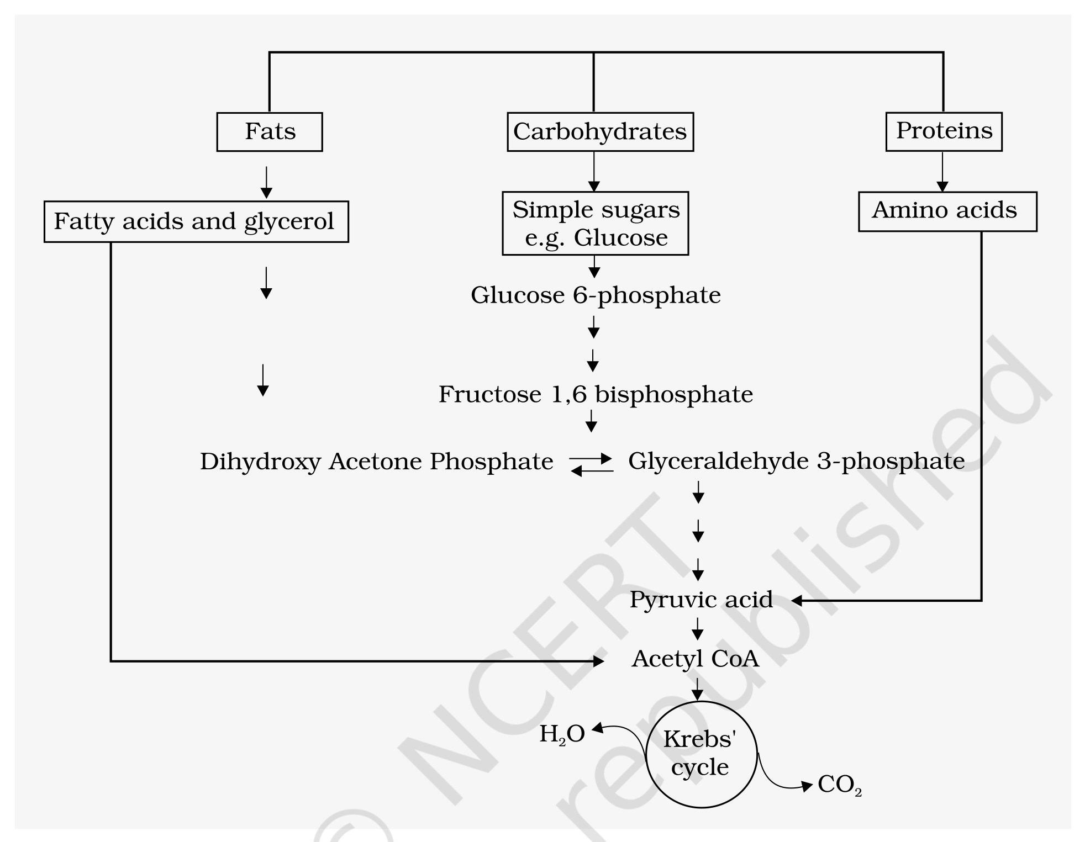
Fig. 12.6 - Interrelationship among metabolic pathways showing respiration mediated breakdown of different organic molecules to CO₂ and H₂O. Fats, Carbohydrates and Proteins enter from the top as fatty acids and glycerol, simple sugars e.g. glucose, and amino acids. The sugar arm runs glucose 6-phosphate to fructose 1,6 bisphosphate to the trioses dihydroxy acetone phosphate and glyceraldehyde 3-phosphate and on to pyruvic acid; every arm converges on acetyl CoA and the Krebs cycle, from which H₂O and CO₂ leave. Every arrow runs one way into the pathway except the dihydroxy acetone phosphate to glyceraldehyde 3-phosphate step, which is the single reversible (two-way) arrow on the plate.
12.7 | Respiratory Quotient

Let us now look at another aspect of respiration.
• Respiratory quotient (RQ) or respiratory ratio: the ratio of the volume of CO₂ evolved to the volume of O₂ consumed in respiration.
RQ = volume of CO₂ evolved / volume of O₂ consumed
The respiratory quotient depends upon the type of respiratory substrate used during respiration.
Respiratory substrate | RQ | Why
Carbohydrates (completely oxidised) | 1 | Equal amounts of CO₂ and O₂ are evolved and consumed, respectively: RQ = 6CO₂ / 6O₂ = 1.0
Fats | Less than 1 | For tripalmitin: 2(C₅₁H₉₈O₆) + 145O₂ yields 102CO₂ + 98H₂O + energy, so RQ = 102CO₂ / 145O₂ = 0.7
Proteins | About 0.9 | When proteins are respiratory substrates the ratio would be about 0.9.

[NOTE] These clean values are textbook cases: in living organisms, respiratory substrates are often more than one; pure proteins or fats are never used as respiratory substrates.

[MEMORY AID - not in NCERT] RQ falls in the alphabetical order of the substrates - Carbohydrate 1.0, Protein 0.9, Fat 0.7 is not alphabetical, but C > P > F is: the more oxygen a substrate still needs, the lower its RQ, and fat is the most hydrogen-rich of the three.

Recap | Quick Recap

• Plants unlike animals have no special systems for breathing or gaseous exchange. Stomata and lenticels allow gaseous exchange by diffusion, and almost all living cells in a plant have their surfaces exposed to air.
• The breaking of C-C bonds of complex organic molecules by oxidation leading to the release of a lot of energy is called cellular respiration. Glucose is the favoured substrate for respiration; fats and proteins can also be broken down to yield energy.
• The initial stage of cellular respiration takes place in the cytoplasm. Each glucose molecule is broken through a series of enzyme catalysed reactions into two molecules of pyruvic acid; this process is called glycolysis.
• The fate of the pyruvate depends on the availability of oxygen and the organism. Under anaerobic conditions either lactic acid fermentation or alcohol fermentation occurs, and fermentation takes place in many prokaryotes, unicellular eukaryotes and in germinating seeds - releasing less than seven per cent of the energy in glucose for a net gain of two ATP.
• In eukaryotic organisms aerobic respiration occurs in the presence of oxygen. Pyruvic acid is transported into the mitochondria where it is converted into acetyl CoA with the release of CO₂. Acetyl CoA then enters the tricarboxylic acid pathway or Krebs' cycle operating in the matrix of the mitochondria.
• NADH + H⁺ and FADH₂ are generated in the Krebs' cycle. The energy in these molecules as well as that in the NADH + H⁺ synthesised during glycolysis are used to synthesise ATP.
• This is accomplished through a system of electron carriers called electron transport system (ETS) located on the inner membrane of the mitochondria. The electrons, as they move through the system, release enough energy that are trapped to synthesise ATP; this is called oxidative phosphorylation. In this process O₂ is the ultimate acceptor of electrons and it gets reduced to water. Net theoretical yield: 38 ATP per glucose.
• The respiratory pathway is an amphibolic pathway as it involves both anabolism and catabolism. The respiratory quotient depends upon the type of respiratory substance used during respiration - 1 for carbohydrates, 0.7 for fats (tripalmitin) and about 0.9 for proteins.

